Walk 14 Ruckhall
Last walked in July 2017

Description. A 5 km (3.1 mile) walk across fields, along narrow roads and touching the Wye River where a small climb is involved. Very good views.
Start. Clehonger. Explorer Map 189 Grid 452377.
Direction from Tesco’s roundabout (Turn milometer to zero). Take the A465 to Abergavenny and at the second turning on the R you TR for ‘Clehonger 2’. In Clehonger, after 2.7 miles you TL, signed ‘Village Hall’, and park along Birch Hill Road. Entrance to the village hall is a few hundred yards on the L.

1. Clehonger Primary School. Walk down the tarmac drive to reach the village hall/school and TL, the hall is now on your R as you walk on across the grass to go thru a small wooden gate onto the main road to Hereford. Cross the main road and TL, after about 30m you TR and walk down a public footpath and thru a kissing gate into F1. Walk down the middle of the field, bearing off to the R, and go thru a small metal gate in the far R corner, into F2. With the hedge and woods on your L you walk along the edge of this field, when you get near to the end of the field, about 80m away, you TL and go thru a small metal gate in the hedge. Go down a muddy track and thru 2 metal gates and some wooden steps to reach the bottom and cross over a wooden footbridge. About 20m further on you TL(ignore gates on your R), and walk across F3 that maybe quite marshy, to go thru some brambles and cross over another wooden footbridge in the far L corner into F4. Walk up the field a few paces then TR, and keeping the brook on your R you walk across a large field (field might be split in two) to cross over a stile, (there are farm buildings on your L, at the top of the hill) into F5. Keep the brook on your R as you cross another large field, when the brook bends to the R you continue on across the field to cross a stile/metal gate onto a road.

2. Ruckhall Mill. TR, walk along the road and TL at the first junction, heading for Ruckhall. The road goes up hill then levels off, and when it bends to the L you TR and go along a road that’s opposite a red telephone and red postbox (ignore the first turning R). After about 40m you bear off to the R and go along an enclosed narrow hedged lane. The lane bends to the R, further on it reaches a set of wooden gates into the Ancient Camp. TL just before the gates and go along a bridleway for about 10m to a track junction where you TR. Walk along a narrow ledged track, looking at the view across the River Wye as you cross a flight of steps and keep on ahead into the woods, (ignore the steps going down to the river, and the few stone steps going up to an old inn). Further on you TR and climb a flight of wooden steps, shortly after you go down a flight of steps. Carry on along the track and further on you go down another flight of steps to the riverbank. TR, continue along the riverbank and cross over a stile, just ahead is an old pumping station. Pass R of the old pumping station and along the gated boardwalk then TR, go along for 80m to pass thru a swinging gate/metal gate onto a driveway. TL and go along the driveway, crossing a bridge, and then going passed Tuck Mill cottage and house that is on your R, to reach a metal gate. Go thru the gate and up a woodland path to go thru another metal gate into F6. TR and skirt around the woods to go thru another metal gate into F7. Bear slightly L and go across the field and down towards the road. Pass thru a metal gate onto the road and TL.

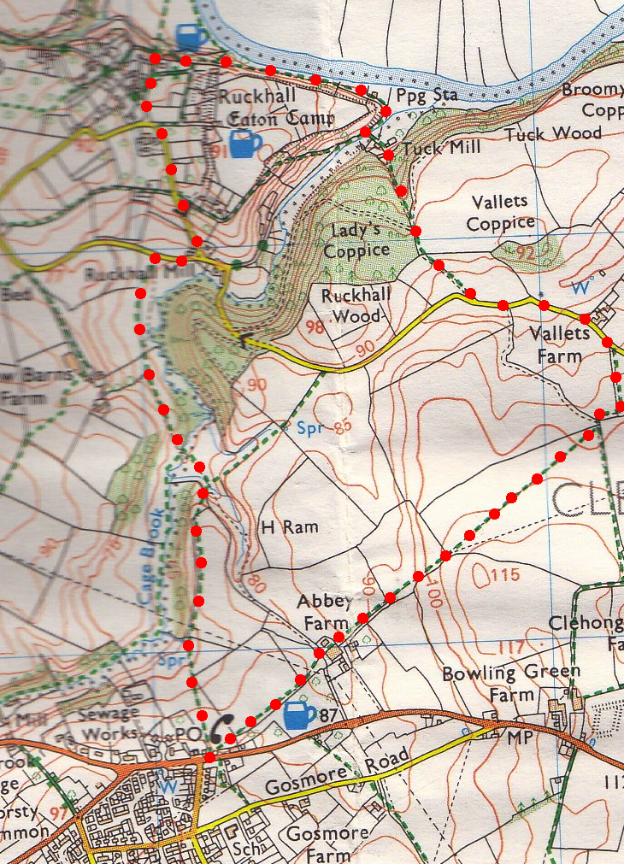
3. Vallets Farm. Continue along the road. 100m passed Vallets Farm, (which is on your L), TR and go thru a metal gate into F8. With the hedge on your R, climb up the field edge to TR thru a kissing gate in the top R hand corner into F9. Walk along the field edge for 40m and TL thru another kissing gate that is directly under power lines, into F10. Head across a vast field, and in the far corner you go thru a kissing gate into a sloping field F11. The Black Mountains can be seen in the distance, and closer to hand you can see the three big satellite dishes at Madley Earth Station. Continue on in the same direction, keeping to the field edge, and walk down to the field corner. There are two gaps in front of you going into two different fields, you take the way marked gap
2
on the R and continue in the same direction keeping to the L field edge, the hedge is on your L. At the bottom of the field is an old wooden barn. Go to the R past a wooden barn and on thru a metal gate. Head up the field to pass thru another metal gate in the top L hand corner, into an orchard. Continue on in the same direction, with the hedge on your L, to pass thru a kissing gate into a field. Walk on to the far corner where you TL and go thru a kissing gate, then onto the road. Cross the road and TL, walk a short distance and TR thru a small wooden gate. The village hall and your transport is just ahead.
3

1

